Katie Kouril
CSD340 – Module 5.2 Assignment
bioSite Outline
April 19, 2026
Color Palette:
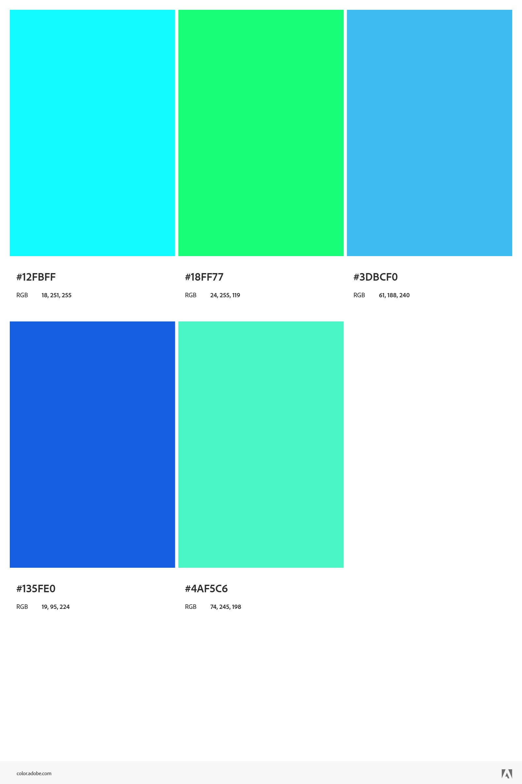
Primary Colors
- #135FE0 — Primary brand blue; best for headers, primary buttons, links.
- #3DBCF0 — Light accent blue; ideal for secondary buttons, info states, highlights.
Accent Colors
- #12FBFF — Vibrant aqua; great for highlights, badges, hover states.
- #18FF77 — Neon green; use sparingly for success states or emphasis.
- #4AF5C6 — Soft mint; good for backgrounds, subtle accents, cards.
Usage
- Keep #135FE0 as the anchor color for consistency.
- Use #12FBFF and #18FF77 sparingly to avoid visual overload.
- Pair #3DBCF0 and #4AF5C6 for calm, readable UI sections.
Typography:
Font Family: Roboto
Hierarchy
- H1: 32–40px, bold, primary color (#135FE0)
- H2: 24–28px, semibold
- H3: 20–22px, semibold
- Body: 16px regular
- Small Text: 14px regular
Line Height: 1.4–1.6 for readability
Letter Spacing: Slightly tightened for headings, normal for body text
Use a consistent 4- or 8-point grid.
- Spacing Scale: 4, 8, 12, 16, 24, 32, 48, 64
  - Rules
- Use larger spacing for section breaks.
- Keep internal component padding consistent (e.g., 12–16px).

Primary Button
- Background: #135FE0
- Text: White
- Hover: Darken by 10%
- Radius: 6–8px
- Padding: 12px 20px
Secondary Button
- Background: #3DBCF0
- Text: #0A0A0A
- Hover: Slightly darker tint
Accent Button (Use Sparingly)
- Background: #18FF77
- Text: #0A0A0A
Form Elements:
- Inputs
  - Border: 1px solid #3DBCF0
  - Focus: 2px outline in #12FBFF
  - Background: White or #F7FDFD (mint-tinted)
- Labels
  - Font: 14px semibold
  - Color: #135FE0
- Error States
  - Border: 1px solid #FF4A4A
  - Text: #FF4A4A

Accessibility:
- Maintain 4.5:1 contrast for text.
- Avoid using #12FBFF or #18FF77 for text on light backgrounds.
- Ensure focus states are visible and high-contrast.
- Provide text alternatives for color-coded indicators.
Interview questions and answers with Adam Szabelak (my brother):
- What are your favorite hobbies?
Video games – horror games like the Resident Evil series and first-person shooters like Halo and Call of Duty.
Traveling – Road trip from Florida -> Colorado -> New Jersey -> Colorado -> Florida
After moving to Florida from New Jersey, I moved to Colorado for a few years for my son to finish high school, had a fun time traveling along the coasts.
- What is your most and least favorite food and why?
Most favorite is pizza – it’s something I miss living in Florida especially being from New Jersey. Thankfully there is an owner of a pizza restaurant who is from New Jersey close by and I can get good pizza once a week from them.
Least favorite is eggplant parmesan, just about the worst food there is on the planet.
- What is your biggest accomplishment?
Being a single father and raising my son, Derek.
- What is your deepest regret?
Not saving money sooner – spent too much when it could have been saved and didn’t have it when I needed it the most in life.
- What is something you are most proud of?
My son Derek going into the army.
- What is something you would like to forget?
Getting hit by a car in 2005 – became disabled for a back injury. Was walking Derek in a stroller across the street when he was six months old, thankfully I received all the damage and my son was safe.
- What is something you are most looking forward to this year (2026)?
My sisters are getting married both in the same year Katie (March 2026) and Megan (October 2026). One wedding down and one more to go.
- What is your most prized possession?
DVD collection – have a massive collection of all my favorite movies I’ve seen over the years, still growing as I find more.
- What are your top three favorite movies?
Drop Dead Fred, Stepbrothers, and Masters of the Universe (1987)
- If you could have lunch with anyone alive or dead, who would you eat with and why?
Jensen Ackles and Jared Padalecki from Supernatural, because they are generally great people and I would love to sit down and have a nice lunch and conversation with them.
About page short bio:
A lifelong fan of horror video games and first-person shooters, he finds joy in everything from the eerie tension of Resident Evil to the adrenaline of Halo and Call of Duty. Travel has shaped much of his life as well — especially the long road trip looping from Florida to Colorado to New Jersey and back again. After moving from New Jersey to Florida, he later relocated to Colorado so his son, Derek, could finish high school, turning those years into a stretch of memorable coastal adventures.
Food is a simple but meaningful part of his story. Nothing beats a good New Jersey pizza, something he misses deeply while living in Florida — though he’s lucky enough to have a nearby pizzeria run by a fellow Jersey native who keeps the tradition alive. On the opposite end of the spectrum sits eggplant parmesan, which he considers one of the worst foods imaginable.
His proudest accomplishment is raising his son as a single father, and watching Derek join the army remains one of the moments that fills him with the most pride. Not everything has been easy, though. He carries the regret of not saving money earlier in life, and the memory he wishes he could forget is the 2005 accident in which he was struck by a car while pushing Derek in a stroller. He took the full impact, resulting in a disabling back injury — but his son was unharmed, something he remains grateful for every day.
This year brings something joyful to look forward to: both of his sisters are getting married, one in March and one in October, and celebrating those milestones has become a highlight of 2026.
Among his possessions, his massive DVD collection stands out as his most treasured — a growing archive of the movies he’s loved over the years. His top favorites include Drop Dead Fred, Step Brothers, and Masters of the Universe (1987). And if he could share a lunch with anyone, living or dead, he’d choose Jensen Ackles and Jared Padalecki from Supernatural, simply because they seem like genuinely good people, he’d enjoy talking with.

Images to be used:
Adam in his suit for Katie’s wedding.
Adam, Derek and Adam’s father for one of Derek’s awards in the army.
Some pictures of video games for hobbies and a picture of a road trip for Adam’s trip to Florida/Colorado/NJ.
